Fishing Regulation Proposal Form A – Special Regulation
Proposed Regulation
Panfish-10 bag in total
Current Regulation
Panfish-25 bag in total
Author  Heath Benike-Fisheries Biologist-Eau Claire |  | Date  9-17-13
Location Information
Affected water(s)
Hodge Lake
County(ies)  Chippewa | WBIC(s)  1853700
Upstream/downstream boundaries, if applicable – Law Enforcement should be consulted
None
Description of the Water and Fishery

Provide a brief description of the water(s)
Hodge Lake is a soft water (MPA=5) 38 acre undeveloped wilderness seepage lake located in northern Chippewa County with a maximum depth of 28 feet. Prior to 2012, this lake was located on private property and within a girl scout camp. Limited to no fishing occurred on the water. In 2012, the Department purchased this property which included Hodge Lake and the lake is now in public ownership. Public access is now provided by a walk-in access of 0.5 miles from a nearby service road. Tentative plans are to maintain and provide a walk-in access fishing experience. The fishery consists of largemouth bass, bluegill, black crappie and yellow perch.

What is the stocking history over the past 20 years? What are the current stocking plans for the future?

No stocking is planned or occurring.

Have there been any significant management actions (e.g. habitat work, chemical reclamation, etc.) or major anthropogenic disturbances (e.g. water quality changes, invasives, water level manipulations etc.) on the water in the past 20 years?

The largest management action was acquiring this parcel in public ownership during 2012. A 2013 spring fyke net survey was completed to assess the panfishery.

How often was the waterbody surveyed in the past 20 years and what type of surveys were conducted?

The water was surveyed in late-spring of 2013 to assess the status of the panfishery via fyke nets.

Management Goal
Summary statement that characterizes the desired fishery (for example, provide a naturally reproducing harvest-oriented walleye fishery; provide a high density bass fishery that maximizes predation on smaller fishes).

Maintain and provide a high quality pan fishing experience by reducing the daily bag limit which will reduce angler harvest on this small seepage lake which was largely unexploited before the Department purchased it.

Justification
Current Problem
How is the management goal not being met with the current regulation? Provide available information to demonstrate the problem.

Now that the lake is in public ownership, the existing statewide bag limit of 25 fish in total for panfish on this small lake will not likely maintain a high quality panfish angling experience.

Basis for Special Regulation
Is the proposed regulation in the toolbox? Use survey data or provide context for a similar water or group of waters (e.g. lake type, spatial proximity) to demonstrate how the proposed regulation will help meet the management goal.

The proposed 10 bag limit is currently in our approved toolbox. (Side Note: The Panfish team is evaluating possible future regulation options for the toolbox and that information will not be available until Feb of 2014, if different options are available at that time; I would be willing to consider other alternatives).

Sampling of the lake in the spring of 2013 indicated, bluegill (N=146) were the most common panfish collected followed by black crappie (N=4) and yellow perch (N=3). The bluegill CPE was 24 fish/net lift. The length frequency of bluegill from 2013 is presented in (Figure 1). More specifically a high quality size structure is present with RSD-8 at 65% and RSD-9 at 16%.

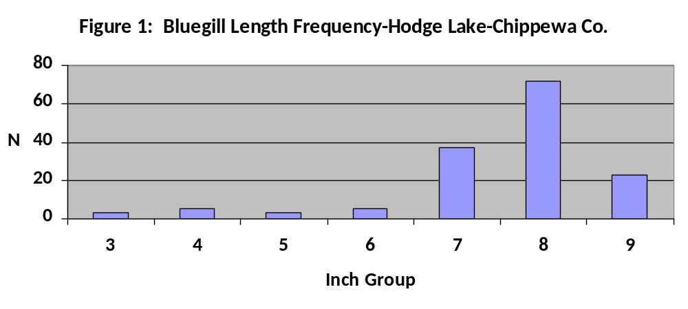

Growth of bluegill was average for age 3-4 fish and above average for age 5-10 fish (Figure 2). The current bluegill fishery is rare for lakes in northern Chippewa County. Most similar soft water seepage lakes in northern Chippewa County have high densities of bluegill with relatively poor growth and size structure. Hodge Lake is the exception to this rule and should be managed to prevent this from occurring.
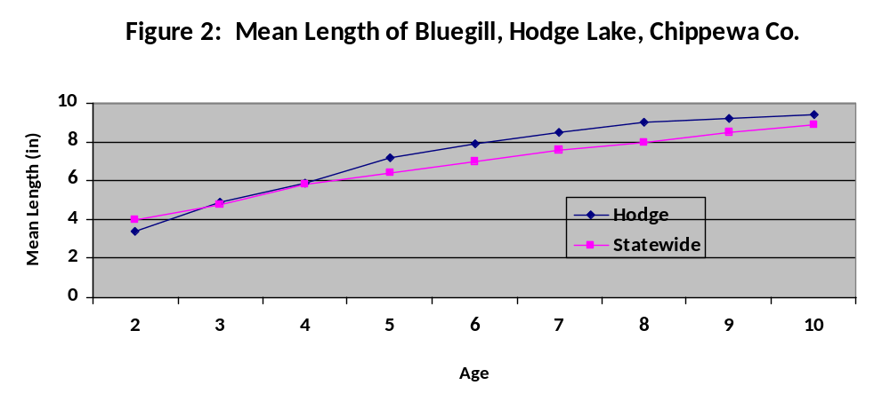

Management Objectives of the Proposed Regulation
Objectives are used to evaluate the effectiveness of your action and determine if you have achieved your goal.

Maintain the existing high quality size structure of the bluegill fishery with RSD-8 and RSD-9 above 50 and 10 respectively.

Evaluation
When and how will the above objectives be measured and evaluated? What is the sampling schedule for this water including frequency and planned protocols?

This water will be sampled on a 8 year rotation to assess the status of the pan fishery assuming funding for such work is present.

Will the proposed regulation affect Ceded Territory water? Yes _X_ No __

If the water is usually declared and speared for tribal harvest, what is the typical bag limit adjustment for sport harvest regulations? Not speared.

Are there any anticipated impacts to tribal fisheries? No.

Are tournaments held on this water? Yes __ No _X_
If yes, please briefly describe frequency and type of tournaments.
Other factors When developing this proposal, did you consider:
Fish contaminant/consumption advice? Yes _X_
How the regulations would affect males and females differently? Yes _X_
Predator – prey interactions? Yes X__
Habitat availability? Yes _X_
Effects of hooking mortality? Yes _X_
Attraction of additional angling pressure, if applicable? Yes X__
Alteration of nutrient cycling, if applicable? Yes __X

Proposal Instigation
Was this regulation change initially a Conservation Congress advisory question, requested by a lake association or another public group, or is it based on biological survey and other data you collected? Please describe.

This proposal was co-lead by our Parks staff who manages the existing property. Their goal was to preserve the high quality angling experience that is present in Hodge Lake. This regulation proposal should help accomplish that. Secondly, survey data confirms a quality pan fishery is present. Small lakes are highly vulnerable to overharvest of panfish and considering public access is now available it seems reasonable to move forward with the 10 bag limit proposal rather than being reactive with a regulation change at some future point if and when the quality of the pan fishery was reduced and then waiting years until the fishery reverts back to a more quality angling experience.

Public Participation
Was input solicited from stakeholders when developing the proposed regulation change? Include any contacts made with local Conservation Congress representatives, lake associations, angler groups, etc.

No organized fishing groups are in/on Hodge Lake. The Natural Resources Board did tour the water in 2013 and they appeared receptive to managing the lake for a quality pan fishery given its undeveloped wilderness setting and small size.

Draft Question
This will be the question in the spring hearing questionnaire. Please use terms understandable to the general public using the following format.
This proposal would apply: 10 bag in total for panfish.

The management goal is: Maintain a quality panfishery on a small lake in a wilderness setting,

This regulation proposal is one tool to help meet the management goal because: It should reduce angler harvest to a more reasonable level for a small seepage lake.

Do you favor applying a 10 bag limit for panfish, in Hodge Lake, Chippewa County?

Example question:
This proposal would apply a 10 daily bag limit for panfish in Hodge Lake, Chippewa County. The current regulation is a 25 bag limit for panfish.

The management goal is to protect a high quality pan fishery that is currently is present in Hodge Lake. In 2012 the Department purchased Hodge Lake which is an 38 acre undeveloped lake that was formally in private ownership. A 2013 fish survey documented that over 50% of the bluegill in Hodge Lake were larger than 8 inches. Considering the lakes small size as well as public access now being present, overharvest of panfish is likely. This regulation should help ensure a desirable and quality sized panfishery is maintained in the future and this regulation should provide a quality panfishery in a wilderness setting which is limited in Chippewa County.

Do you favor applying a daily bag limit of 10 for panfish on Hodge Lake in Chippewa County?

Regulation Proposal Checklist

Fish Team Supervisor

Reviewer  Justine Hasz | Date  11-20-13
Are adequate data presented to justify the regulation change? Yes x No

Is there adequate documentation that the proposed regulation will achieve the desired stated outcome?
Yes x No

Are the management objectives clear and complete? Yes x No

Reviewer Comments: (Is there additional information you want the author to provide before approving the proposal?)

Recommended Action: Approve x Reject

District Fish Supervisor
Reviewer  Bob Hujik | Date  12-17-13
Is the proposal necessary? -enforceable? -complete? Yes x No

Does the proposal meet the district’s goal for providing varied fishing opportunities? Yes x No

Is the proposed regulation easy for anglers to comply with and understand? Yes x No

Reviewer Comments: (Is there additional information you want the author to provide before approving the proposal?) We would entertain a 5-bag on this lake if it were available.

Recommended Action: Approve x Reject

Species Team
Reviewers  Joanna Griffin and Jon Hansen on behalf of the Panfish Team | Date  04/21/2014
Are adequate data presented to justify the regulation change? Yes x No

Does the proposal fit with statewide species management goals? Yes x No

Does the proposal meet regional and statewide goals for varied fishing opportunities? Yes x No

Are the management objectives clear and complete? Yes x No

Reviewer Comments: (Is there additional information you want the author to provide before approving the proposal?)
This is a unique proposal in that it requests a conservative regulation for the sake of protection. While this type of approach is generally approached with caution (usually based on logic behind the classic saying: “if it ain’t broke don’t fix it”) however this lake is particularly unique because of the change to access. A high quality opportunity exists with minimal to no fishing pressure which will likely change because of a land and access acquisition. The parks staff is interested in managing this water for a unique quality, pristine fishing experience and given the relative paucity of these types of populations and experiences, the Bass Team feels it is justified to proactively offer a quality regulation.

Recommended Action: Approve x Reject

Law Enforcement Comments:
Please provide comments on enforceability of the reg proposal and other issues you think the Fisheries Management Board should consider.

